CAR MODIFICATION BUSINESS WEBSITE
SPECIFICATIONS, INFORMATION DESIGN TAXONOMY, AND TECHNICAL BRIEF
- INTRODUCTION
This document outlines the website specifications, information design taxonomy, and technical brief for a car modification and maintenance business website. The website will function as an online platform where customers can learn about services, book maintenance or modification appointments, and purchase car parts through an online catalogue.
The platform aims to improve customer convenience, streamline workshop scheduling, and expand the business by allowing online parts ordering and service booking.
- PURPOSE OF THE WEBSITE
The primary purpose of the website is to provide an online system that allows customers to:
• View available car modification and maintenance services
• Book maintenance and modification appointments online
• Browse a catalogue of car parts and accessories
• Order car parts directly from the website
• Learn more about the company and its services
The website will also allow administrators to manage bookings, products, and customer orders efficiently.
- TARGET USERS
Primary Users
The main users of the website include:
• Car owners seeking maintenance services
• Car enthusiasts interested in performance upgrades
• Customers searching for car modification parts
Secondary Users
Secondary users include:
• Workshop mechanics and staff
• Website administrators who manage bookings and product listings
- WEBSITE FEATURES
4.1 Online Booking System
The website will provide an appointment booking system that allows customers to schedule maintenance or modification services.
Users will be able to:
• View available appointment dates
• Select a specific service
• Book a preferred date and time
• Receive booking confirmation
• Reschedule or cancel bookings if necessary
The booking form will collect the following information:
• Customer name
• Phone number
• Email address
• Vehicle make and model
• Requested service
• Preferred booking date
• Additional notes or special requests
4.2 Car Parts Catalogue
The website will include a product catalogue that displays available car parts and accessories.
Customers will be able to:
• Browse available parts
• Search for specific products
• Filter products by category or vehicle type
• View product prices
• View detailed product descriptions
Each product page will display:
• Product name
• Product images
• Product price
• Detailed description
• Compatibility with vehicle types
• Availability status
4.3 Online Ordering System
The platform will allow customers to purchase car parts directly from the website.
Customers will be able to:
• Add products to a shopping cart
• View items in their cart
• Proceed to checkout
• Enter shipping or collection details
• Select a preferred payment method
Possible payment methods include:
• Card payments
• Mobile payments
• Bank transfers
• Pay on collection
4.4 Services Page
The services section will display all modification and maintenance services offered by the business.
Examples of services include:
• Engine tuning
• Suspension upgrades
• Body kit installation
• Exhaust system modifications
• Brake upgrades
• General vehicle maintenance
Each service page will include:
• Service description
• Estimated pricing
• Estimated service duration
• A direct booking option
4.5 User Accounts
The website may include optional user accounts that allow customers to create personal profiles.
Registered users will be able to:
• Track their orders
• View booking history
• Save vehicle information for future bookings
• Manage their account details
4.6 Admin Dashboard
The website will include an administrative dashboard where business staff can manage website operations.
Administrators will be able to:
• Manage appointment bookings
• Add, update, or remove products from the catalogue
• Update product prices
• View and manage customer orders
• Manage user accounts
• Upload and manage product images
- INFORMATION DESIGN AND TAXONOMY
Information design refers to how content is structured and organized within the website to ensure easy navigation and user experience.

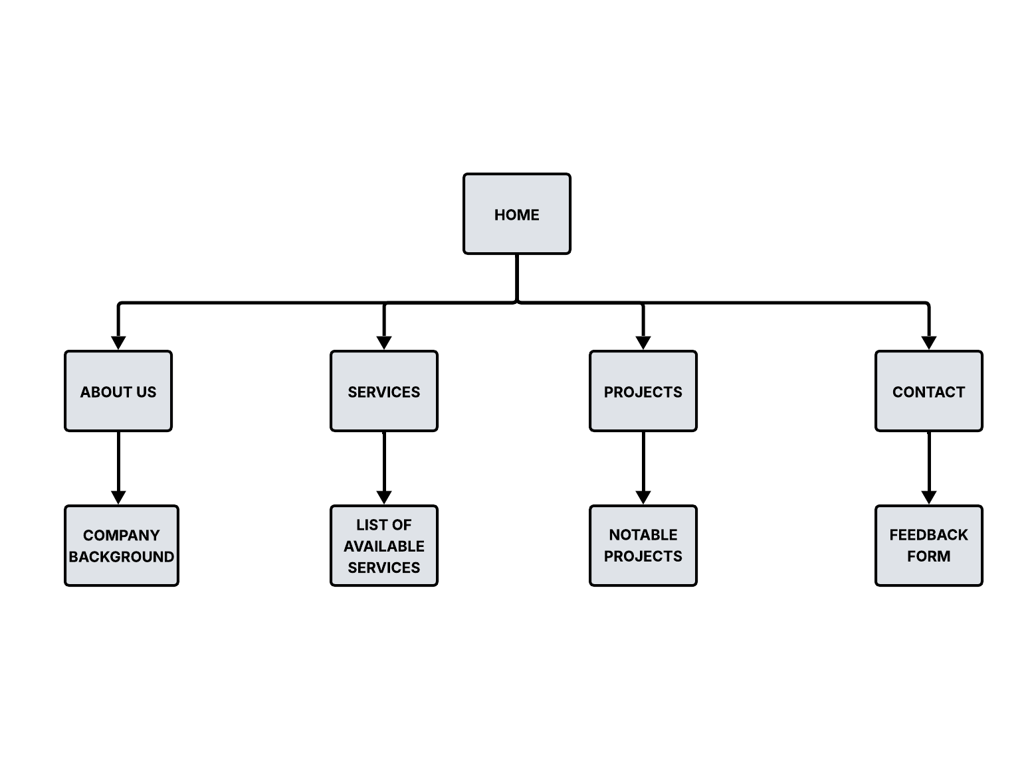
5.1 Main Navigation Structure
The main website navigation will include the following sections:
Home
Services
Parts Catalogue
Book Appointment
Shop / Cart
About Us
Contact
5.2 Services Categories
The services section will be divided into categories such as:
• Maintenance Services
• Performance Upgrades
• Exterior Modifications
• Interior Modifications
5.3 Parts Catalogue Categories
The product catalogue will organize parts into categories including:
• Engine Parts
• Suspension Systems
• Exhaust Systems
• Wheels and Tires
• Brake Components
• Interior Accessories
5.4 Website Sitemap
Home page
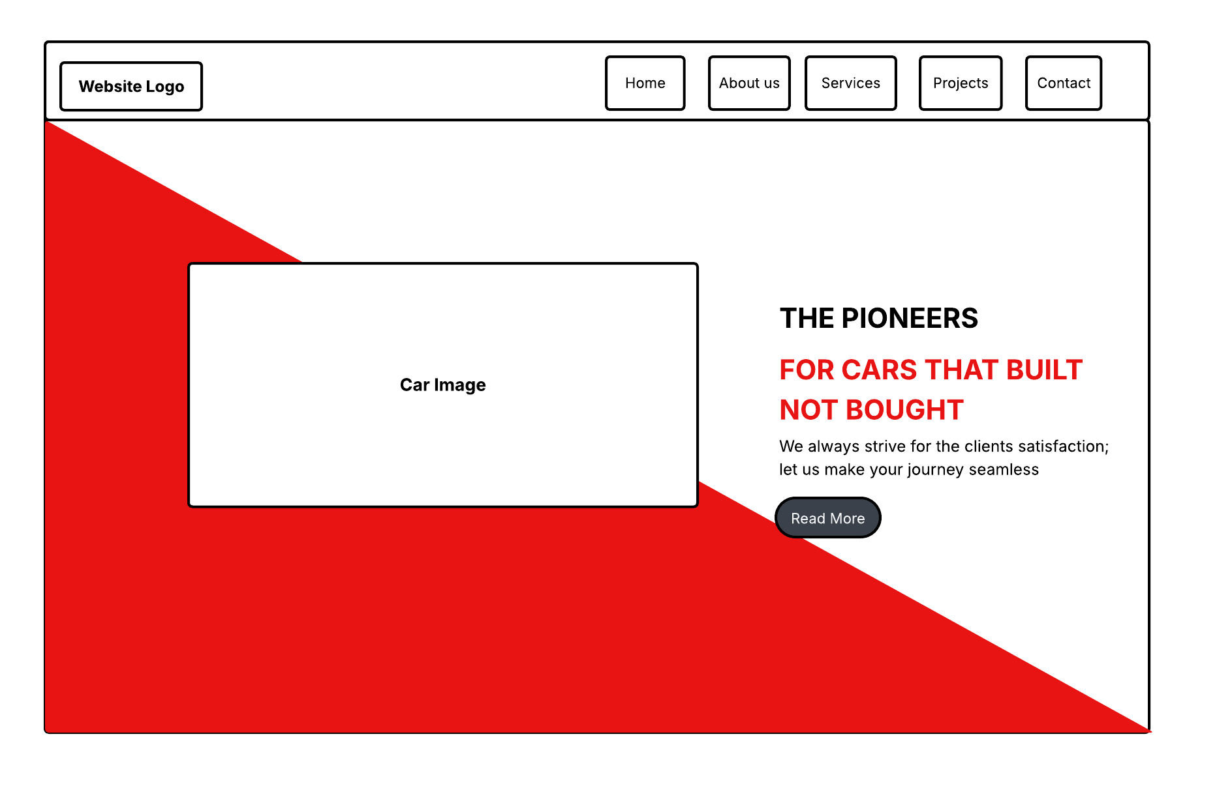
About Us page
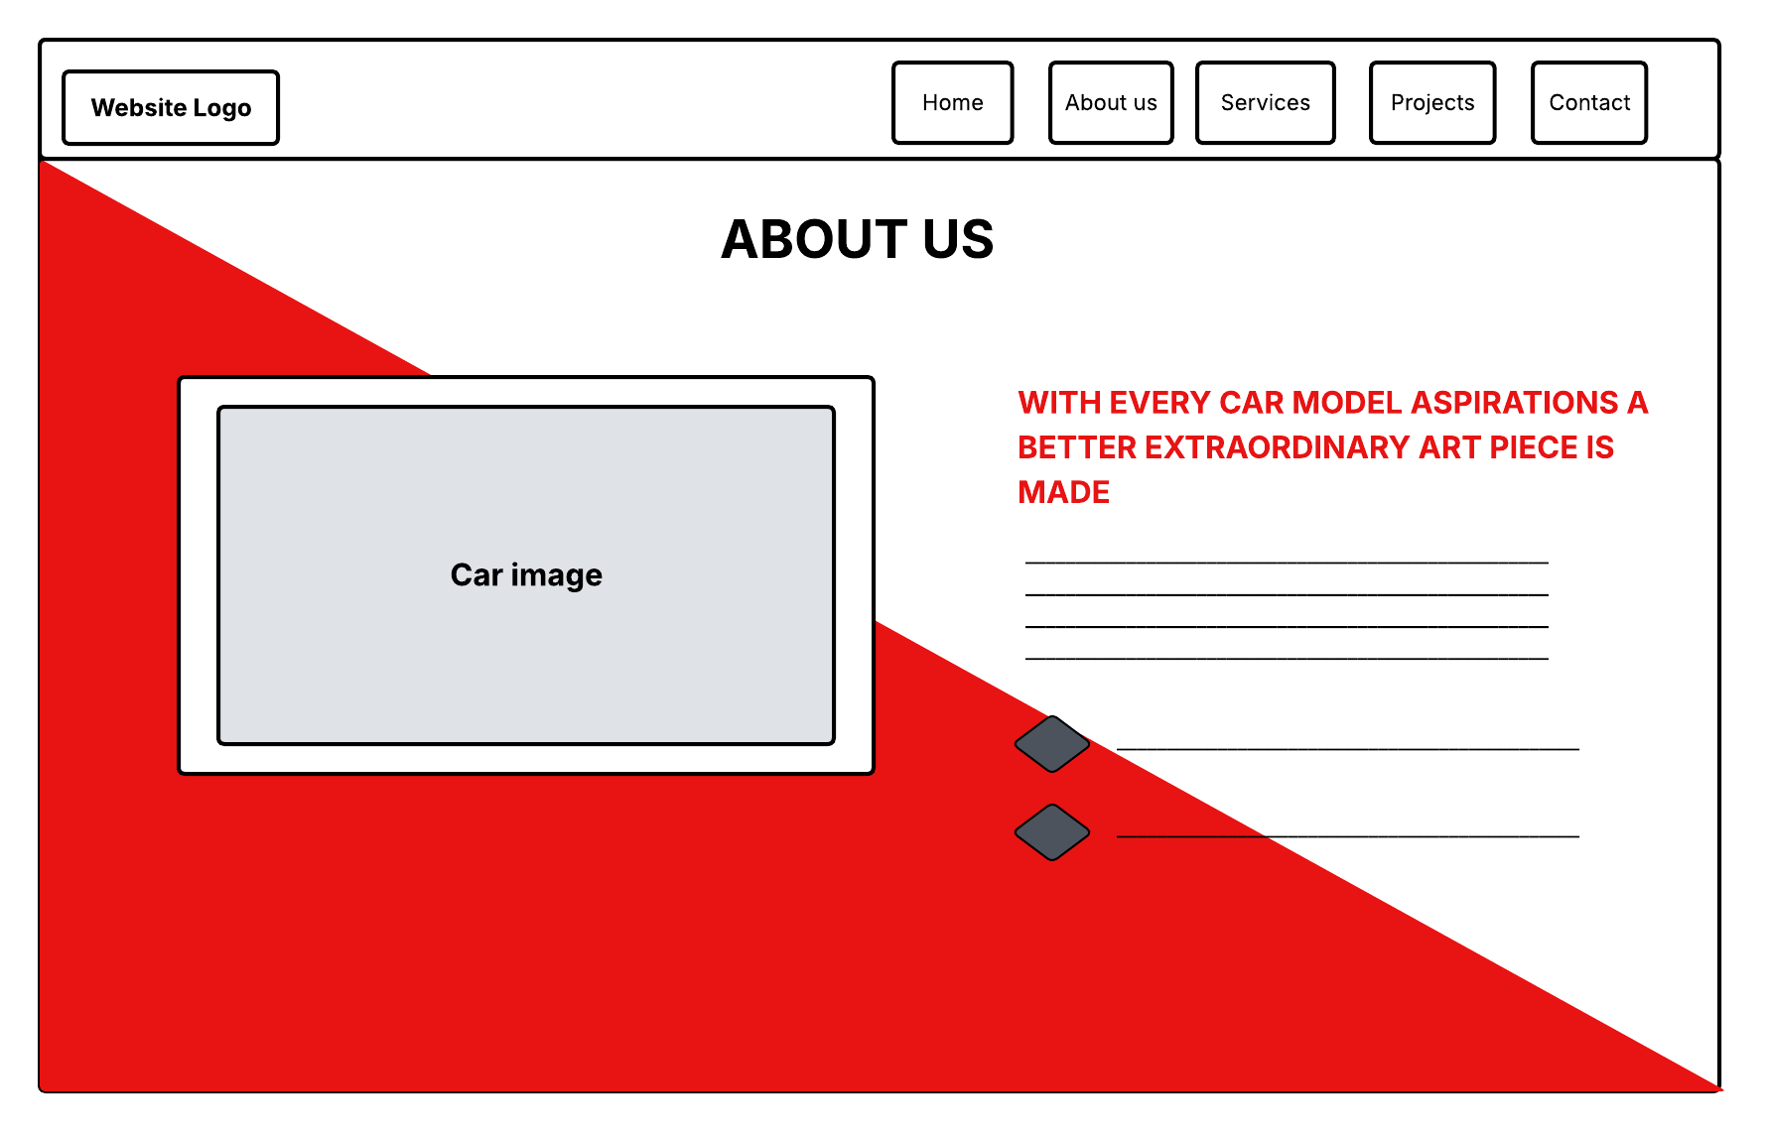
Services page
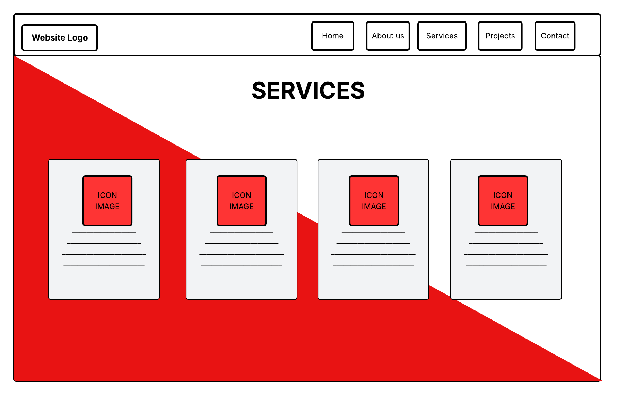
Projects page
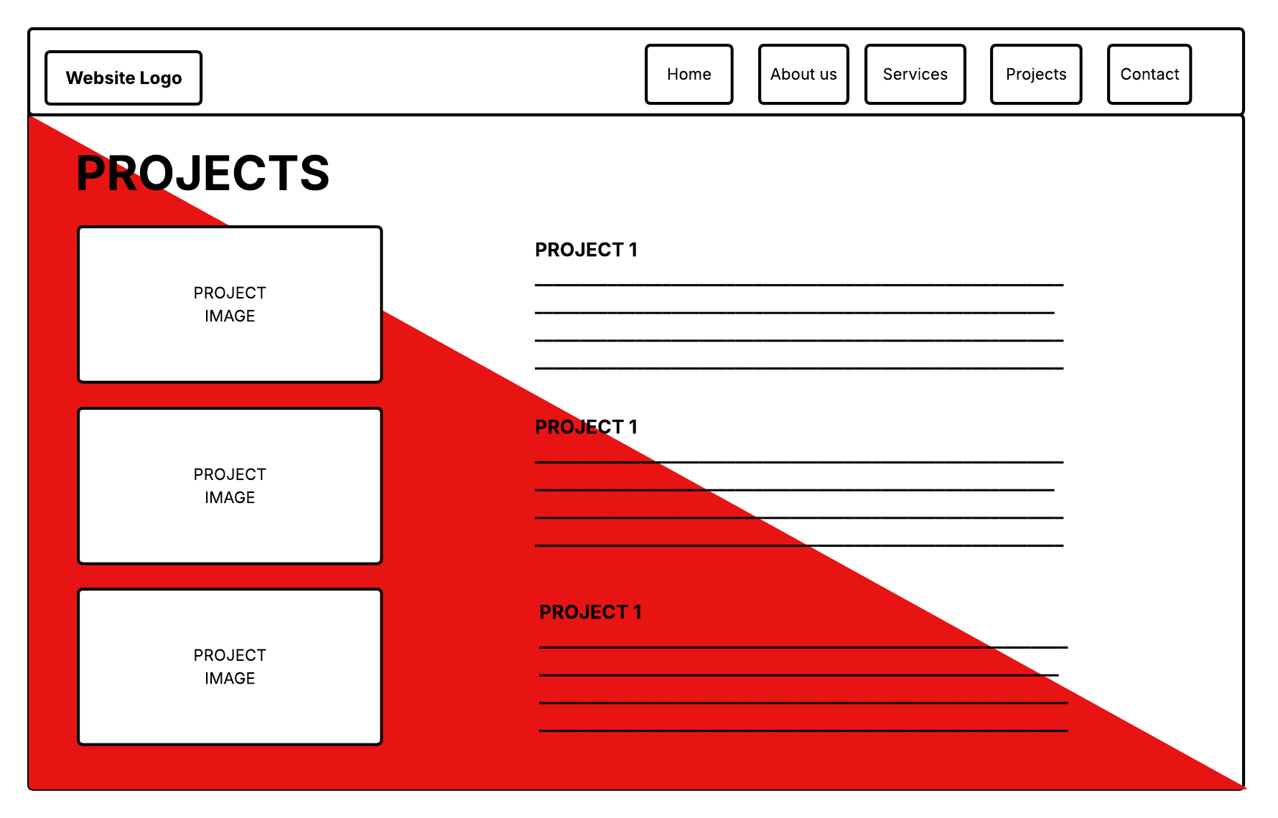
Contact page
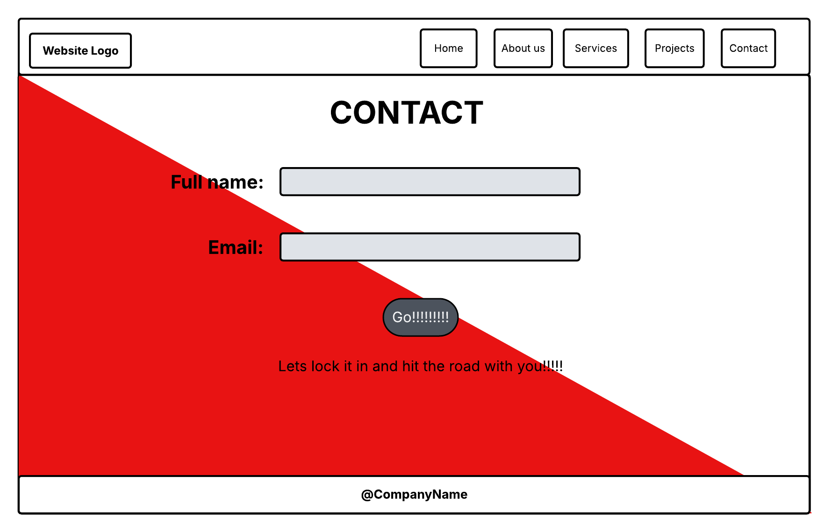

Home
Services
- Maintenance
- Engine Tuning
- Suspension Upgrades
- Body Modifications
Parts Catalogue
- Engine Parts
- Suspension
- Exhaust
- Wheels
- Accessories
Book Appointment
Shop
- Cart
- Checkout
About Us
Contact

5.5 Homepage Content Structure
The homepage will include the following sections:
Hero Section
This area will display branding, images of modified vehicles, and a call-to-action encouraging users to book services or explore parts.
Featured Services
A section highlighting the most popular modification services offered by the workshop.
Popular Products
A display of frequently purchased or featured car parts.
Quick Booking Section
A direct link or form allowing customers to quickly schedule appointments.
Customer Testimonials
Feedback from satisfied customers to build trust and credibility.
Contact Information
Business address, phone number, and operating hours.
- TECHNICAL BRIEF
The technical brief describes the technologies and system architecture required to build the website.
6.1 Development Platform Options
Custom Web Application
The website will be built as a custom web application. This approach provides greater flexibility and scalability but requires more development time and technical expertise.
A custom system typically includes:
Frontend Technologies
• HTML5
• CSS
• JavaScript

